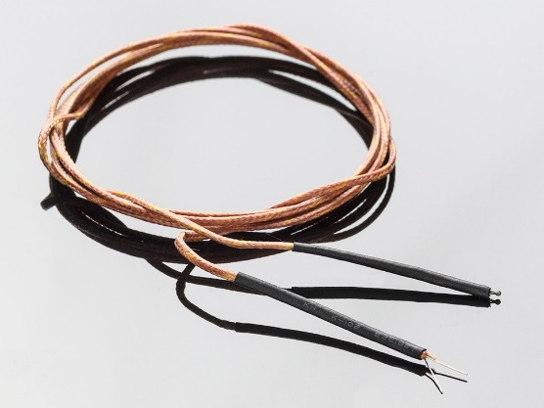

DESCRIPTION

Thermocouples are best used for measuring temperatures that can go above 100 °C. This is a bare wires bead-probe which can measure air or surface temperatures. Most inexpensive thermocouples have a vinyl covering which can melt at around 200 °C, this one uses a fiberglass braid so it can be used in high temperature measurements such as heaters and ovens. There's a small piece of heat shrink on the end to keep the fiberglass from fraying. If you're using at >250°C temperatures, simply remove it with a small blade.

* K type thermocouple with glass over-braiding
* Good up to 500 °C (900 °F)!
* Color-coded wires
* 1 meter long (a little more than 3 feet)
* [Best used with a thermocouple amplifier such as the MAX6675 or MAX31855](http://www.adafruit.com/products/269)

TECHNICAL DETAILS

Dimensions:

* + Length: 1m/39.5in
  + Thickness: 2.18mm/0.09in
  + Weight: 7.18g/0.26oz

**Link to Dealer:** *http://www.adafruit.com/products/270*